THIS AGENDA IS SUBJECT TO CHANGE WITH MINIMUM 24 HOURS NOTICE
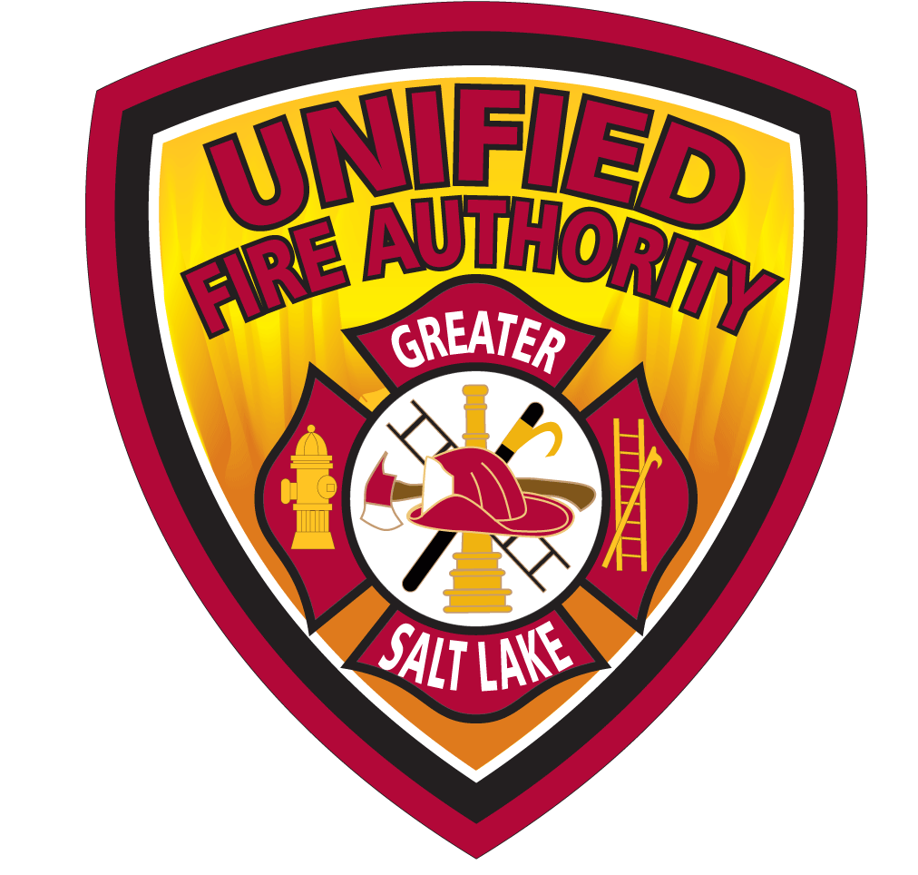
UNIFIED FIRE AUTHORITY BOARD AGENDA
February 18, 2025, 7:30 a.m.
NOTICE IS HEREBY GIVEN THAT THE UNIFIED FIRE AUTHORITY BOARD OF DIRECTORS SHALL ASSEMBLE BOTH ELECTRONICALLY AND IN-PERSON FOR A MEETING AT UFA HEADQUARTERS LOCATED AT
3380 SOUTH 900 WEST, SALT LAKE CITY, UT 84119

THE PUBLIC MAY ATTEND IN-PERSON OR ELECTRONICALLY VIA ZOOM WEBINAR AT:
https://zoom.us/j/98255960431?pwd=VW9iWk1KQ0JYTi9lSDIxMS96KzZXZz09
Password: 123911

- Call to Order – Chair Weichers

- Public Comment
Please limit comments to three minutes each and be germane to the agenda items or UFA business. The UFA Board typically will not engage directly but may direct staff to address comments following the meeting.
There are three options for comments during this meeting:
  - In-Person.
  - Live during the Webinar by logging in as described above. If you wish to make a comment, select the “Raise Hand” button at the bottom of the screen. You will then be added to the queue and invited to speak.
  - EMAIL: Public comments will be accepted prior to the meeting via email at
publiccomment@unifiedfire.org until 7:00 a.m. February 17, 2025. Emailed comments submitted prior to 7:00 a.m. February 17, 2025, will be read or summarized into the record, comments received after the deadline will be forwarded to the UFA Board, but not read into the meeting record or addressed during the meeting.
- Minutes Approval – Chair Weichers PAGE 1/TAB 1
  - January 21, 2025
I, (state name), move to approve the minutes from the January 21, 2025,
UFA Board Meeting as submitted
Please unmute for verbal vote

- Administer Oath of Office for New Board Members – Cyndee Young, Clerk

- Annual Board Member Requirements – CLO Roberts time? PAGE 5/TAB 2
  - Code of Ethics Review
  - Conflict of Interest Policy Review
  - Designation of Alternate
  - State Auditor Training Reminder

- Consent Agenda PAGE XX/TAB 3
  - Review of January Disbursements – CFO Hill
I, (state name), move to approve consent agenda items as submitted
Please unmute for verbal vote

- Public Hearing to Receive and Consider Comments on Proposed
Amendments to the 2024/2025 Fiscal Year Budget – CFO Hill PAGE XX/TAB 4
I, (state name) move to open the Public Hearing to receive and consider
comments on proposed amendments to the 2024/2025 Fiscal Year Budget
Roll Call Vote

I, (state name) move to close the Public Hearing to receive and consider
comments on proposed amendments to the 2024/2025 Fiscal Year Budget
Roll Call Vote

- Consider Resolution 02-2025A to Approve Amendments to the
2024/2025 Fiscal Year Budget – CFO Hill PAGE XX/TAB 4
I, (state name) move to approve Resolution 02-2025A amending the
2024/2025 Fiscal Year Budget as presented
Roll Call Vote

- Committee Updates
  - Benefits & Compensation Committee
– Chair Silvestrini
    - Meetings held 1/23/25 & 2/13/25
    - Next meeting 3/13/25
  - Governance Committee (No meeting) – Chair Silvestrini
  - Finance Committee (Next meeting 4/10/25) – Chair Henderson

- Administration & Planning Report – AC Pilgrim PAGE XX/TAB 5
  - Legislative Update
  - 2024 Accomplishments Poster

- Support Services Report – AC Robinson
  - EM Hazardous Mitigation Plan – EM Manager Behunin

- Operations Report – AC Dern PAGE XX/TAB 6
  - Incident Highlight
  - Canyon Response Update

- Fire Chief Report
  - Introduction to Women FF Class UFRA – Labor VP Swenson
  - Federal Funding Update

- Possible Closed Session
None
Yes -xxx Discussion
Roll Call Vote

I, (state name), move to temporarily recess the meeting to convene in a closed session to discuss matters as provided by Utah Code Annotated §52-4-205

The Board may consider a motion to enter Closed Session. A closed meeting described under Utah Code Section 52-4-205 may be held for specific purposes including, but not limited to:
- discussion of the character, professional competence, or physical or mental health of an
individual;
b. strategy sessions to discuss pending or reasonably imminent litigation;
c. strategy sessions to discuss the purchase, exchange, or lease of real property;
d. discussion regarding deployment of security personnel, devices, or systems; and
e. investigative proceedings regarding allegations of criminal misconduct.
A closed meeting may also be held for attorney-client matters that are privileged pursuant to Utah Code § 78B-1-137, and for other lawful purposes that satisfy the pertinent requirements of the Utah Open and Public Meetings Act.

Re-Open the Meeting
I, (state name), move to re-open the meeting to the public
Roll Call Vote

- Adjournment – Chair Weichers
I, (state name), move to adjourn the February 18, 2025, UFA Board Meeting
Please unmute for verbal vote

Upcoming Events

Awards Banquet – May 3
Fire School 101– March 21
Graduation – May 14

The next UFA Board meeting will be held March 18, 2025, at 7:30 a.m. both electronically and at
UFA Headquarters located at 3380 South 900 West, Salt Lake City, UT 84119

THE PUBLIC IS INVITED TO PARTICIPATE IN ALL UFA MEETINGS.
In accordance with the Americans with Disabilities Act, UFA will make reasonable accommodation for participation in the meetings. Please call the clerk at least three working days prior to the meeting at 801-743-7213. Motions relating to any of the foregoing, including final action, may be taken at the meeting. This meeting will also be held electronically to allow members of the UFA Board to participate. This agenda is subject to change with a minimum 24-hour notice.

CERTIFICATE OF POSTING
The undersigned, does hereby certify that the above agenda notice was posted on this 17th day of February, 2025, on the UFA bulletin boards, the UFA website www.unifiedfire.org , posted on the Utah State Public Notice website http://www.utah.gov/pmn/index.html and was emailed to at least one newspaper of general circulation within the jurisdiction of the public body.
Cynthia Young, UFA Board Clerk

