THIS AGENDA IS SUBJECT TO CHANGE WITH MINIMUM 24 HOURS NOTICE
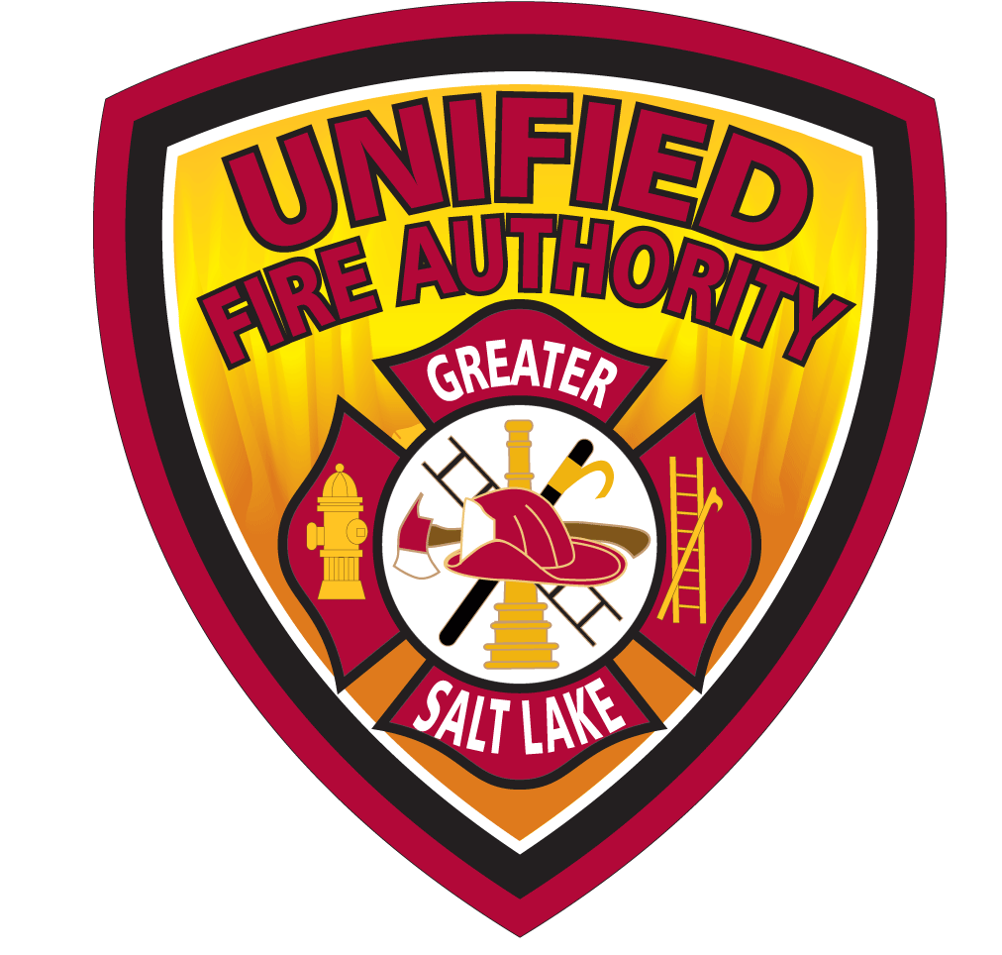
UNIFIED FIRE AUTHORITY BOARD AGENDA
July 15, 2025, 7:30 a.m.
NOTICE IS HEREBY GIVEN THAT THE UNIFIED FIRE AUTHORITY BOARD OF DIRECTORS SHALL ASSEMBLE BOTH ELECTRONICALLY AND IN-PERSON FOR A MEETING AT UFA HEADQUARTERS LOCATED AT
3380 SOUTH 900 WEST, SALT LAKE CITY, UT 84119

THE PUBLIC MAY ATTEND IN-PERSON OR ELECTRONICALLY VIA ZOOM WEBINAR AT:
https://zoom.us/j/98255960431?pwd=VW9iWk1KQ0JYTi9lSDIxMS96KzZXZz09
Password: 123911

- Call to Order – Chair Weichers

- Public Comment
Please limit comments to three minutes each and be germane to the agenda items or UFA business. The UFA Board typically will not engage directly but may direct staff to address comments following the meeting.
There are three options for comments during this meeting:
  - In-Person.
  - Live during the Webinar by logging in as described above. If you wish to make a comment, select the “Raise Hand” button at the bottom of the screen. You will then be added to the queue and invited to speak.
  - EMAIL: Public comments will be accepted prior to the meeting via email at
publiccomment@unifiedfire.org until 7:00 a.m. July 14, 2025. Emailed comments submitted prior to 7:00 a.m. July 14, 2025, will be read or summarized into the record, comments received after the deadline will be forwarded to the UFA Board, but not read into the meeting record or addressed during the meeting.
- Mayor Silvestrini Service Award – Chair Weichers

- Board Elections – CLO Roberts
  - Chair Election
  - Vice Chair

- Minutes Approval – Chair
  - June 17, 2025 Board Meeting
  - June 17, 2025 Special Board Meeting – Fee Increase

- Consent Agenda – CFO Hill
  - Review of June Disbursements

- Committee Updates
  - Benefits & Compensation Committee (No meeting) – No Chair
  - Governance Committee (No meeting) – Chair Gettel
  - Finance Committee (No meeting) – Chair Henderson

- Administration & Planning Report – AC Russell
  - Liaison Format Change

- Support Services Report – AC Robinson
  - UFA/BLM WL Fire Station Update

- Operations Report – AC Dern

  - Holiday Staffing
  - Herriman Incident
  - Type VI Staffing Prioritization

- Fire Chief Report
  - Hot Shot Update
  - Lithium Ion Batteries – DOC Easton/FM Watkins
  - USAR Update – AC Russell

- Possible Closed Session
The Board may consider a motion to enter Closed Session. A closed meeting described under Utah Code Section 52-4-205 may be held for specific purposes including, but not limited to:
- discussion of the character, professional competence, or physical or mental health of an
individual;
b. strategy sessions to discuss pending or reasonably imminent litigation;
c. strategy sessions to discuss the purchase, exchange, or lease of real property;
d. discussion regarding deployment of security personnel, devices, or systems; and
e. investigative proceedings regarding allegations of criminal misconduct.
A closed meeting may also be held for attorney-client matters that are privileged pursuant to Utah Code § 78B-1-137, and for other lawful purposes that satisfy the pertinent requirements of the Utah Open and Public Meetings Act.
Re-Open the Meeting

- Adjournment – Chair

The next UFA Board meeting will be held August 19, 2025, at 7:30 a.m. both electronically and at
UFA Headquarters located at 3380 South 900 West, Salt Lake City, UT 84119

THE PUBLIC IS INVITED TO PARTICIPATE IN ALL UFA MEETINGS.
In accordance with the Americans with Disabilities Act, UFA will make reasonable accommodation for participation in the meetings. Please call the clerk at least three working days prior to the meeting at 801-743-7213. Motions relating to any of the foregoing, including final action, may be taken at the meeting. This meeting will also be held electronically to allow members of the UFA Board to participate. This agenda is subject to change with a minimum 24-hour notice.

CERTIFICATE OF POSTING
The undersigned, does hereby certify that the above agenda notice was posted on this 14th day of July, 2025, on the UFA bulletin boards, the UFA website www.unifiedfire.org , posted on the Utah State Public Notice website http://www.utah.gov/pmn/index.html and was emailed to at least one newspaper of general circulation within the jurisdiction of the public body.
Micayla Dinkel, UFA Board Clerk

