2023 Local Firework Shows

June 3 (10pm) – Pony Express Days Fireworks Show – Eagle Mountain
June 23/24 (10pm) - Taylorsville Dayzz Fireworks Show - Valley Regional Park
June 23/24 (10pm) - Fort Herriman Town Days Fireworks Show - Butterfield Park
July 04 (10pm) - Riverton Town Days Fireworks Show - Riverton City Park
July 01 (8pm) - Stadium of Fire – LaVell Edwards Stadium, Provo
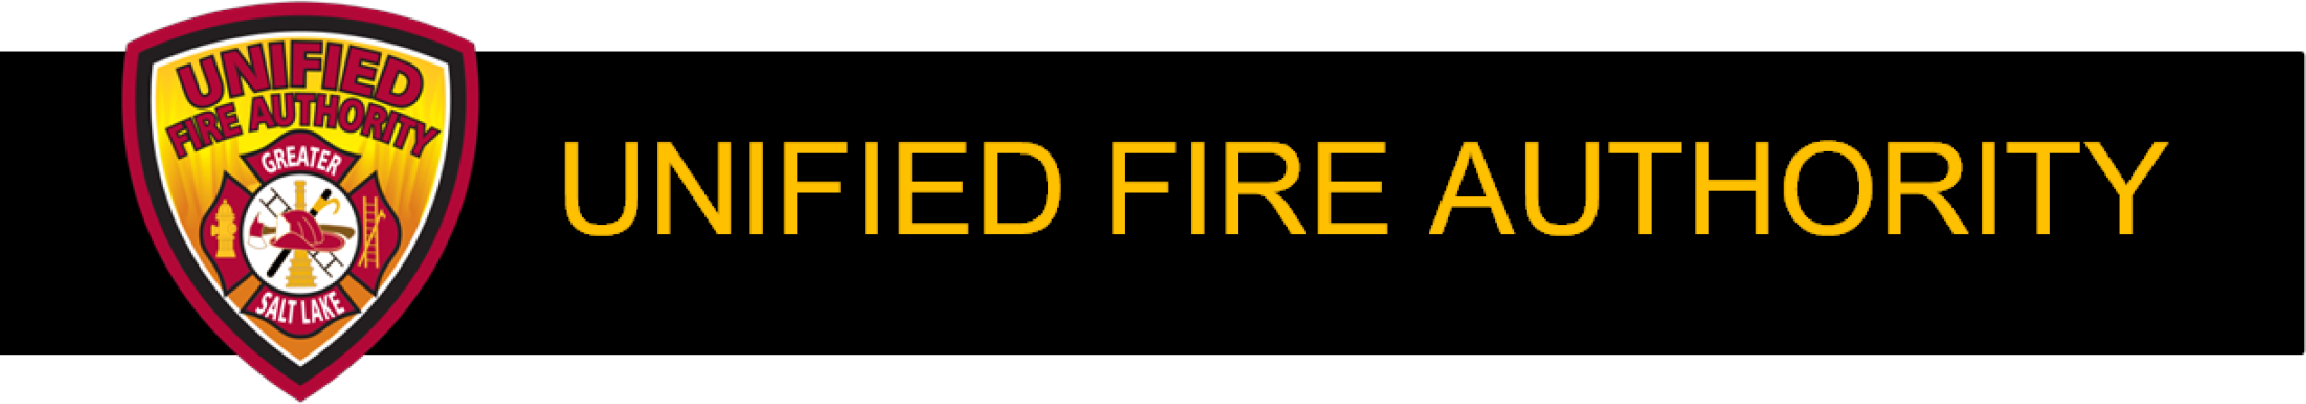
July 04 (10:00) - West Jordan City Fireworks Show - Veterans Memorial Park
July 04 (10pm) - Murray Fun Days Fireworks Show - Murray City Park
July 04 (10pm) - Sandy City Fireworks Show - Sandy City Park
July 04 (dusk) - The Gateway Fireworks Show - The Gateway Downtown
July 04 (dusk) - Magna Independence Day Celebration - Magna Copper Park
July 14/15 - Draper Days Fireworks Show - City Park
July 29 (10pm) - Butlerville Days Fireworks Show - Butler Park
August 05 (10pm) - Harvest Days Festival Fireworks Show - Midvale City Park

3380 South 900 West  Salt Lake City, UT 84119- 4102  (801) 743-7200  www.unifiedfire.org

