Rachael K. Staebell

Rachael.Staebell@ColoradoSprings.gov CSFD Station 4

Biography

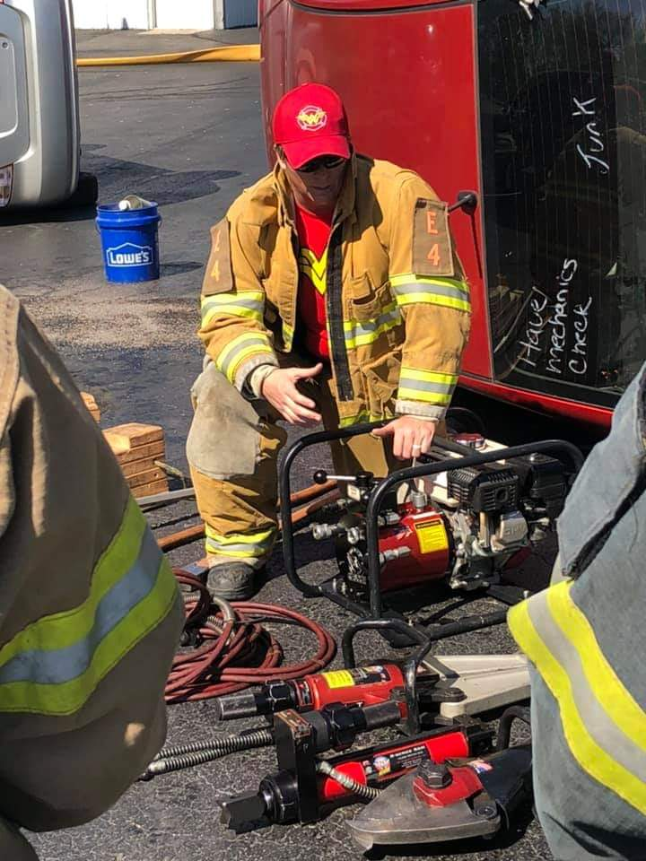
I began my career in public safety in 2000 as an EMT for a local ambulance company. In 2001, I became a volunteer firefighter with the City of Fountain in Colorado and then earned a position as its first paid, full-time female firefighter in 2002. I was hired by Colorado Springs Fire Department in fall of 2005. By 2012, I promoted to the rank of Paramedic; and, in 2016 was promoted to my current rank as Lieutenant. I still perform as a paramedic when needed and currently work at a busy double company fire house. Since 2009, I have been participating in Women in Fire among several other female firefighting organizations. I oversee and conduct Hands On Trainings that further the fireground skills of female firefighters. I truly believe that leadership begins in the backseat. Being comfortable and proficient with basic skills is how we build the base for good leaders. Teaching and mentoring have become my passion. As I was once helped along my journey by other female firefighters, I want to continually pay it forward, and share my journey in the hope that it may help others as they progress in the fire service.

