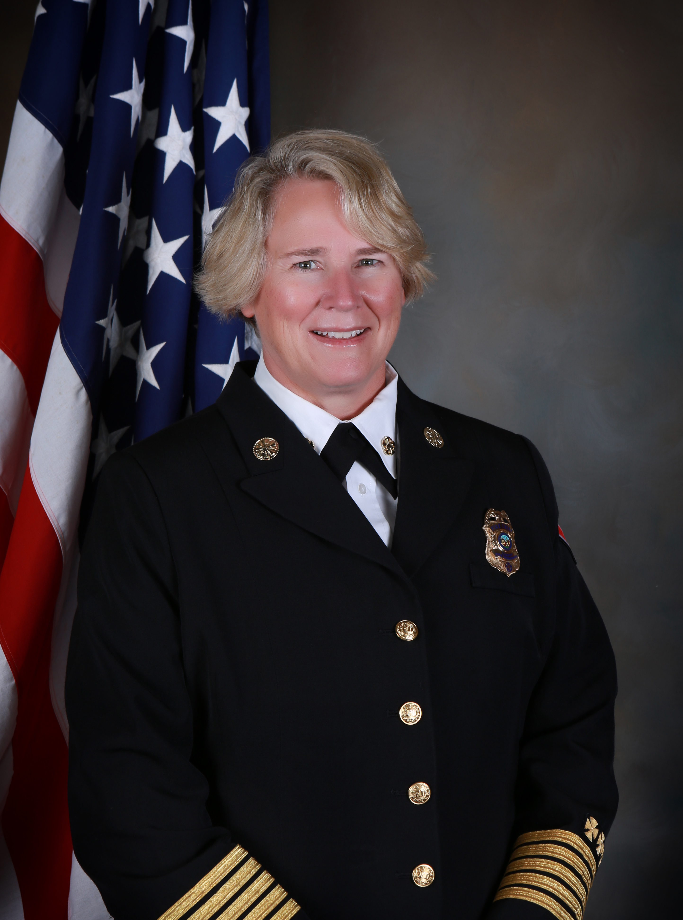

Alicia Leane Welch

When leaders in the fire service are faced with particularly challenging issues, they often turn to Alicia Welch for guidance. Her accomplishments during her nearly 30 years of rising through the ranks of the Los Angeles Fire Department (LAFD) and then serving as Fire Chief of the Golden Fire Department (CO) demonstrate their trust is well placed. Her extensive experience in operations, administration, leadership, management, and special assignments has made her the go-to person throughout her career, locally, regionally, and nationally. The depth and breadth of her experience and education – which continue today – make her uniquely qualified to serve as a leader and a mentor in her profession.

In addition to keeping the communities she’s served safe by responding to and leading incidents such as structure fires, emergency medical calls, events that require special expertise and training such as hazardous materials, Chief Welch has had a tremendous impact on public safety by her behind-the-scenes work that enables first responders around the country to fulfill their mission to save lives and protect property. For example, she has:

- Provided peer support to impacted firefighters during Hurricanes Katrina and Rita as part of the LAFD’s Critical Incident Stress Management Team.
- Identified areas for improving firefighters’ safety by conducting post-incident firefighter fatality investigations as a member of the LAFD’s Significant Incident Investigation Team.
- Created case studies for the LAFD’s renowned Leadership Academy that develops first responder leaders in that and other public safety-related agencies.

In addition, during her one-year assignment as one of three Distinguished Fellows for the U.S. Department of Homeland Security/FEMA, Chief Welch developed a national preparedness model called Ready Responder whose purpose is to enable first responders and their agencies to focus on providing essential services to their communities during disasters by taking steps to prepare their families and departments in advance.

Chief Welch’s commitment to and engagement with the communities she serves directly and indirectly are demonstrated clearly by what she does on and off the job. For example, as the pandemic became a physical and economic threat in 2020, she was asked to serve on the International Association of Fire Chiefs’ (IAFC) COVID Economic Task Force, whose purpose was to prepare fire-rescue agencies to recover from its devastating effects on their personnel, organizations, and communities. She has worked tirelessly to increase the diversity and inclusiveness of her profession. She led the development of the Golden Fire Department’s first strategic plan. Chief Welch has served as a board member for the American Red Cross, promoted, supported, and participated in countless community events, and engaged in community risk reduction initiatives. She leads by example in engaging in continuous learning, and encourages and supports others to do the same.

In addition to earning a Bachelor of Arts Degree at California State University, Long Beach followed by a Master of Arts Degree in Homeland Security/National Studies from the esteemed Naval Postgraduate School in Monterey, California, Chief Welch continued her professional development by completing the International Public Safety Leadership and Ethics Institute’s Leadership Development Studies program and the Los Angeles Police Department’s West Point Leadership program. She is certified as a Colorado Executive Fire Administrator. In 2021 she completed the highly selective IAFC Fire Service Executive Development Institute program.

Chief Welch retired from the LAFD in 2017 and moved to Golden, Colorado where she was an active skier, hiker, and mountain bike rider. Little did she know that her retirement would be short-lived. She was sworn in as the Golden Fire Department’s Fire Chief, the first woman to hold that position in the department’s 140+ year history. In August 2021, she will break another glass ceiling by becoming Fire Chief of the Lompoc Fire Department in California.

